

**Name: Muhammad Mubbashir Khan**

**Sec: B**

**CMS: 465077**

**Task no:**

#include <iostream>

using namespace std;

double average(int arr[], int n) {

int sum = 0;

for (int i = 0; i < n; i++) {

sum += arr[i];

}

return (double)sum / n;

}

int main() {

int numbers[5] = {10, 20, 30, 40, 50};

double avg = average(numbers, 5);

cout << "The average of the array is " << avg << endl;

return 0;

}

**OUTPUT:**

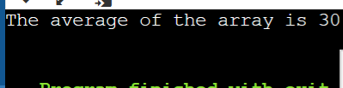

**Task no:2**

#include <iostream>

using namespace std;

// A function to swap two elements

void swap(int *a, int *b)

{

int temp = *a;

*a = *b;

*b = temp;

}

// A function to implement bubble sort

void bubbleSort(int arr[], int n)

{

// Loop through all elements

for (int i = 0; i < n - 1; i++)

{

// Loop through the remaining unsorted elements

for (int j = 0; j < n - i - 1; j++)

{

// If the current element is greater than the next element, swap them

if (arr[j] > arr[j + 1])

{

swap(&arr[j], &arr[j + 1]);

}

}

}

}

// A function to print an array

void printArray(int arr[], int n)

{

for (int i = 0; i < n; i++)

{

cout << arr[i] << " ";

}

cout << endl;

}

// The main function

int main()

{

// Declare an array of 5 integers

int arr[5];

// Take input from the user

cout << "Enter 5 integers: " << endl;

for (int i = 0; i < 5; i++)

{

cin >> arr[i];

}

// Print the original array

cout << "The original array is: " << endl;

printArray(arr, 5);

// Sort the array using bubble sort

bubbleSort(arr, 5);

// Print the sorted array

cout << "The sorted array is: " << endl;

printArray(arr, 5);

return 0;

}

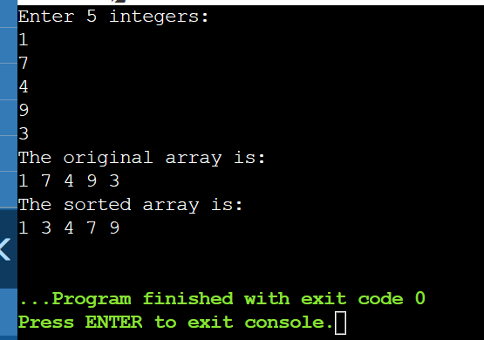

Task no :3

#include <iostream>

using namespace std;

// A function to swap two elements

void swap(int *a, int *b) {

int temp = *a;

*a = *b;

*b = temp;

}

// A function to perform selection sort on an array

void selectionSort(int arr[], int n) {

// Loop through the array from 0 to n-1

for (int i = 0; i < n-1; i++) {

// Find the minimum element in the unsorted part of the array

int min_index = i;

for (int j = i+1; j < n; j++) {

if (arr[j] < arr[min_index]) {

min_index = j;

}

}

// Swap the minimum element with the first element of the unsorted part

swap(&arr[min_index], &arr[i]);

}

}

// A function to print an array

void printArray(int arr[], int n) {

for (int i = 0; i < n; i++) {

cout << arr[i] << " ";

}

cout << endl;

}

// The main function

int main() {

int arr[5];

cout << "Enter 5 integers: " << endl;

for (int i = 0; i < 5; i++) {

cin >> arr[i];

}

cout << "The original array is: " << endl;

printArray(arr, 5);

cout << "The sorted array is: " << endl;

printArray(arr, 5);

return 0;

}

